# Bug Report – Buggy Cars Rating

This report contains five issues found in the Buggy Cars Rating website.

The testing was done using Chrome Version 109.0.5414.120.

## Broken link

**Description**

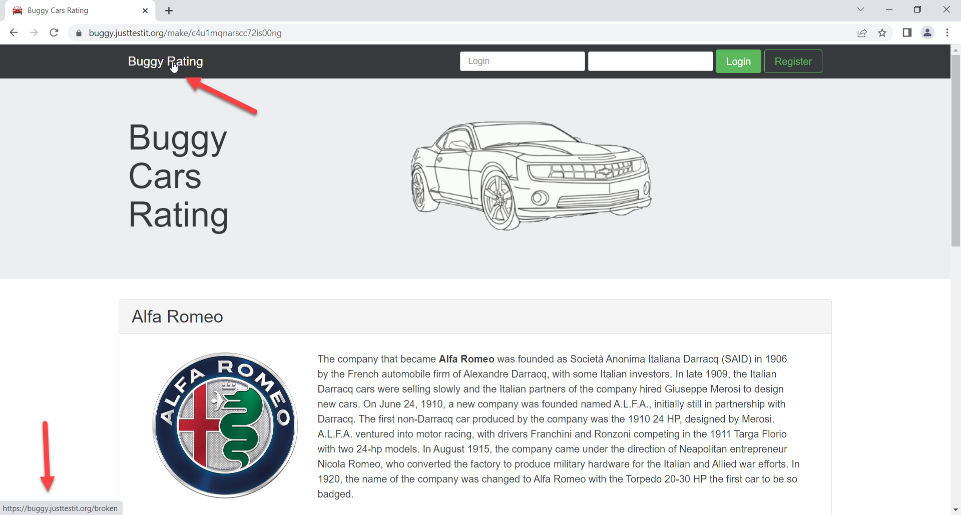

**Steps to Reproduce**

1. Navigate to <https://buggy.justtestit.org/make/c4u1mqnarscc72is00ng>
2. Click “Buggy Rating” on the top left of the page

**Expected Behaviour**

The site should redirect to <https://buggy.justtestit.org/>

**Actual Behaviour**

The site is not redirected. The actual link is <https://buggy.justtestit.org/broken>

## Author data is not being populated

**Description**

“Author” column is not populated under the Model page

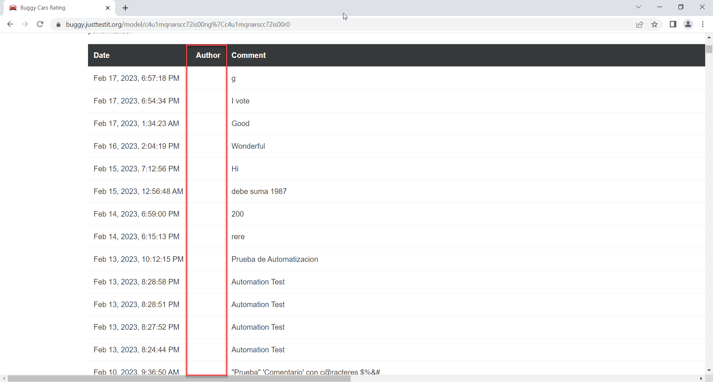

**Steps to Reproduce**

1. Navigate to a model page, e.g. <https://buggy.justtestit.org/model/c4u1mqnarscc72is00e0%7Cc4u1mqnarscc72is00hg>
2. Verify the “Author” column

**Actual Behaviour**

The “Author” column is empty

**Expected Behaviour**

The Author column should be populated with the voter’s identifier (e.g. Name or Login)

## Rank is not being sorted

**Description**

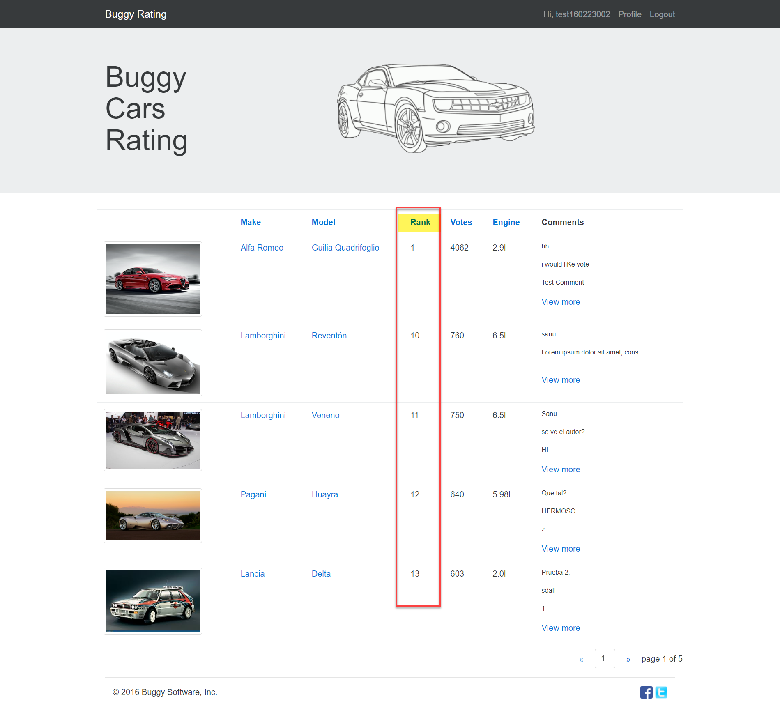

**Steps to Reproduce**

1. Navigate to Overall Rating page, i.e. <https://buggy.justtestit.org/overall>
2. Click Rank link (See highlight in the image above)
3. Verify the order of the displayed models

**Actual Behaviour**

The models are not ordered by “Rank”

**Expected Behaviour**

The models should be ordered by rank ascending or descending. In the example above, the rank should be 1, 2, 3..